**Solmate Project Solution**

**Since**: Wednesday, December 15, 2021

**Version**: 2

**Table of Content**

**1.** **Problem** 2

**2.** **Model Deep Analysis** 2

**3.** **Data Architecture** 3

**3.1.** **Data Model** 3

**3.2.** **Data Size Evaluation in Worst Case** 4

**4.** **Idea** 5

**5.** **Algo Per Use Case** 5

**5.1.** **Stake** 5

**5.2.** **View Reward** 7

**6.** **Tests** 8

**6.1.** **Case I** 8

**6.2.** **Case II** 8

**7.** **Analysis & Conclusion** 23

1. **Problem**

* Previously it’s found that the follow algo can exaust comput unit very soon, just few stekd NFTs can exaust it.

Loop through a slot gap

Loop through (wallet, nfts) over BtreeMap

Loop through nfts

1. **Model Deep Analysis**

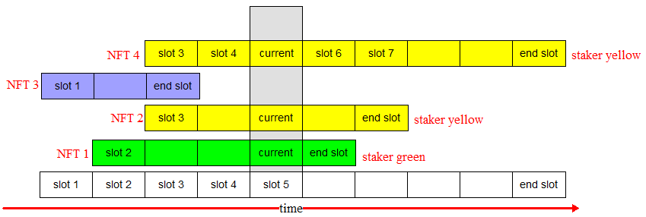

As long as the reward calculation is based on $CIETY emission of per slot, the per slot caculation can’t be avoided, is a MUST, no matter:

* Whether veNFT is used or not
* Whether a outside trigger is empoyed or not

As illustrated in the above diagram, on slot 5,

Staker Yellow contributes 2 cells

Staker Green contrubutes 1 cells

So,

Staker Yellow’s share is: 2/3

Staker Green’s share is: 1/3

Any share calculating mechanism is a variant of this.

1. **Data Architecture**
   1. **Data Model**

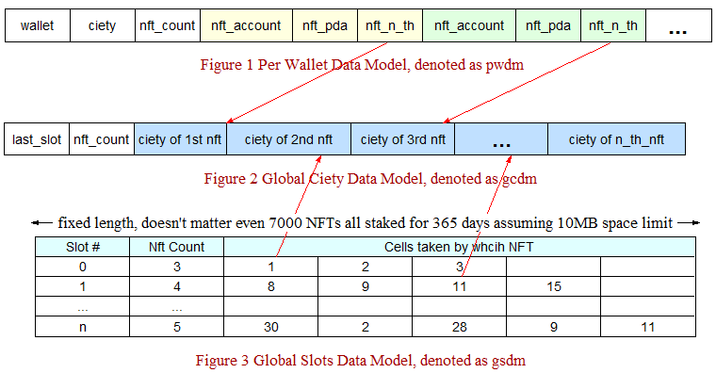

* 1. **Data Size Evaluation in Worst Case**
* Pwdm, wallet(32) + ciety(4) + nft_count(2) + (nft_account(32) + nft_pda(32) + nft_n_th(2)) * 7000 = 462038 bytes, each wallet has an account holding this
* Gcdm, last_slot(2) + nft_count(2) + ciety_of_nth_nft(4) * 7000 = 28004 bytes, globally only one account holding this
* Gsdm, 365 * (slot(2) + nft_count(2) + nft_nth(2) * 7000) = 5111460 bytes = 4992 kb, meaning all NFTs staked for 365 days, globally only one account holding this

1. **Idea**

We used to use to use hilgh capsulated data structure, like Vec and BtreeMap, actually it’s not absolutely necessary given a fixed data volume.

DATA STRUCTURE WITH FIXED STRUCTURE AND SIZES ARE EXTREMELY EFFICIENT, we drop any high level collection struct, like Vec and BtreeMap, instead WE DO EVERYTHING ON RAW BYTES ARRAY DIRECTLY.

1. **Algo Per Use Case**
   1. **Stake**

Input = a wallet + multiple NFTs

Given one time of staking, for each staked NFT:

* nft_nth = gcdm.get(‘nft_count’) + 1, O(1)
* gcdm.set (‘nft_count’, nft_nth), O(1)
* pwdm.add( (nft_account, nft_pda, nft_nth) ), O(3)
* loop all slots taken by given NFT, O( number of slots * 2), 365*2 at most, assuming only one NFT can be staked at one time.
  + gsdm.get(slot).set(‘nft_count’), O(1)
  + gsdm.get(slot).appendOnSlot(nft_nth), O(1)

for example, if right after initialization there is an NFT staked which has a time length 30 days, then all data model will look like this:

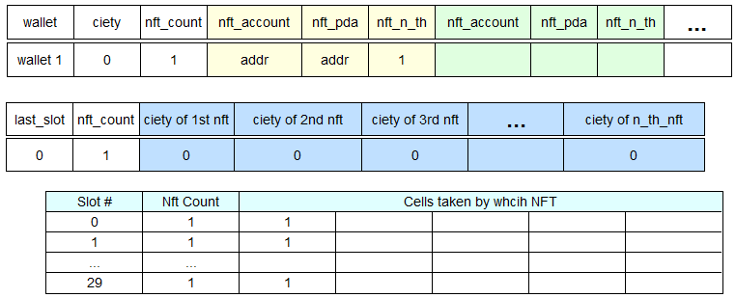

If this staker staked another NFT for 60 days after 10 days, the data models will look like this:

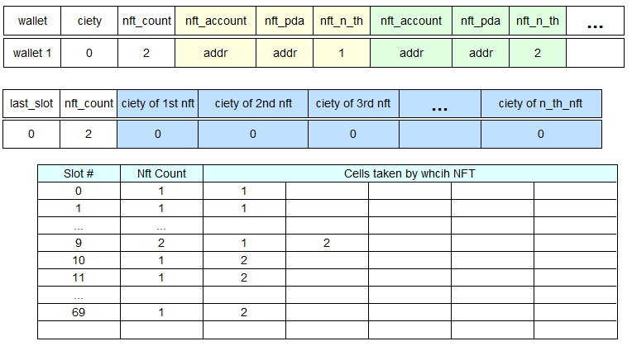

* 1. **View Reward**

Input = a wallet

* Curr_slot = clac_curr_slot(now), O(1)
* Last_slot = gcdm.get(‘last_slot’)
* For slot in [curr_slot, last_slot], worst case O((last_slot – curr_slot)*7000)

For nft_nth in [0, gsdm.nft_count)

Shere = 1/gsdm.nft_count

Accumulate gcdm.ciety on nft_th

* Update gcdm.last_slot
* Calculate total rewards of a staker, for i in [0, pwdm.nft_count), O(pwdm.nft_count * 2)
  + total_ciety = total_ciety + gcdm.getCiety(nft_th)
  + pwdm.set(‘ciety’, total_ciety)

1. **Tests**
   1. **Case I**

* Right after initialization, a staker can stake 21 NFTs for 365 days.
* Only update gsdm, not include any other operations, like escrowing etc
* Remaining compute units are 3501

There MUST be a limit to how many NFTs a staker can stake at one time.

This updates 365 * (2 + 2 + 21*2) = 16790 bytes in 2 levels of nested loops, the time complexity is O(16790).

This big improvement conviced me it may be feasible with the idea of DO EVERYTHING ON RAW BYTES ARRAY DIRECTLY.

* 1. **Case II**

With gsdm, imagine a trigger call the calculation of reward everyday, the worst case is that the slot of calculating day has 7000 NFTs.

This will update 2 + 2 + 7000*2 = 14004 bytes, O(14004) < O(16790), so it’s reasonable that there is no worries of exausting the limited compute units given we have this trigger even in the worst case.

But this doesn’t include updating gcdm.ciety 7000 times and update N wallets’ ciety.

But if we don’t employ a trigger, then there is a balance between slots_gap and num_nfts:

slots_gap * (2 + 2 + num_nfts*2) <=16790

Test I is a simulation of staking though, in case of viewing rewards, algorithmically it’s similar, just writing byets becomes reading bytes, so it’s reasonable in this way to estimate the situation of the case of viewing rewarding.

**In the following estimating resutls based on the above inequality:**

* **slots_gap means how often rewards are viewed by stakers.**
* **num_nfts means an average number of NFTs staked on the slots of a gap**
* **All possible balanced combination are (NOTE: within a gap, on each its slot, it all has num_nfts NFTs):**

slots_gap= 1 num_nfts= 7000

slots_gap= 2 num_nfts= 4196

slots_gap= 3 num_nfts= 2797

slots_gap= 4 num_nfts= 2097

slots_gap= 5 num_nfts= 1678

slots_gap= 6 num_nfts= 1398

slots_gap= 7 num_nfts= 1198

slots_gap= 8 num_nfts= 1048

slots_gap= 9 num_nfts= 931

slots_gap= 10 num_nfts= 838

slots_gap= 11 num_nfts= 762

slots_gap= 12 num_nfts= 698

slots_gap= 13 num_nfts= 644

slots_gap= 14 num_nfts= 598

slots_gap= 15 num_nfts= 558

slots_gap= 16 num_nfts= 523

slots_gap= 17 num_nfts= 492

slots_gap= 18 num_nfts= 465

slots_gap= 19 num_nfts= 440

slots_gap= 20 num_nfts= 418

slots_gap= 21 num_nfts= 398

slots_gap= 22 num_nfts= 380

slots_gap= 23 num_nfts= 364

slots_gap= 24 num_nfts= 348

slots_gap= 25 num_nfts= 334

slots_gap= 26 num_nfts= 321

slots_gap= 27 num_nfts= 309

slots_gap= 28 num_nfts= 298

slots_gap= 29 num_nfts= 288

slots_gap= 30 num_nfts= 278

slots_gap= 31 num_nfts= 269

slots_gap= 32 num_nfts= 261

slots_gap= 33 num_nfts= 253

slots_gap= 34 num_nfts= 245

slots_gap= 35 num_nfts= 238

slots_gap= 36 num_nfts= 232

slots_gap= 37 num_nfts= 225

slots_gap= 38 num_nfts= 219

slots_gap= 39 num_nfts= 214

slots_gap= 40 num_nfts= 208

slots_gap= 41 num_nfts= 203

slots_gap= 42 num_nfts= 198

slots_gap= 43 num_nfts= 194

slots_gap= 44 num_nfts= 189

slots_gap= 45 num_nfts= 185

slots_gap= 46 num_nfts= 181

slots_gap= 47 num_nfts= 177

slots_gap= 48 num_nfts= 173

slots_gap= 49 num_nfts= 170

slots_gap= 50 num_nfts= 166

slots_gap= 51 num_nfts= 163

slots_gap= 52 num_nfts= 160

slots_gap= 53 num_nfts= 157

slots_gap= 54 num_nfts= 154

slots_gap= 55 num_nfts= 151

slots_gap= 56 num_nfts= 148

slots_gap= 57 num_nfts= 146

slots_gap= 58 num_nfts= 143

slots_gap= 59 num_nfts= 141

slots_gap= 60 num_nfts= 138

slots_gap= 61 num_nfts= 136

slots_gap= 62 num_nfts= 134

slots_gap= 63 num_nfts= 132

slots_gap= 64 num_nfts= 130

slots_gap= 65 num_nfts= 128

slots_gap= 66 num_nfts= 126

slots_gap= 67 num_nfts= 124

slots_gap= 68 num_nfts= 122

slots_gap= 69 num_nfts= 120

slots_gap= 70 num_nfts= 118

slots_gap= 71 num_nfts= 117

slots_gap= 72 num_nfts= 115

slots_gap= 73 num_nfts= 114

slots_gap= 74 num_nfts= 112

slots_gap= 75 num_nfts= 110

slots_gap= 76 num_nfts= 109

slots_gap= 77 num_nfts= 108

slots_gap= 78 num_nfts= 106

slots_gap= 79 num_nfts= 105

slots_gap= 80 num_nfts= 103

slots_gap= 81 num_nfts= 102

slots_gap= 82 num_nfts= 101

slots_gap= 83 num_nfts= 100

slots_gap= 84 num_nfts= 98

slots_gap= 85 num_nfts= 97

slots_gap= 86 num_nfts= 96

slots_gap= 87 num_nfts= 95

slots_gap= 88 num_nfts= 94

slots_gap= 89 num_nfts= 93

slots_gap= 90 num_nfts= 92

slots_gap= 91 num_nfts= 91

slots_gap= 92 num_nfts= 90

slots_gap= 93 num_nfts= 89

slots_gap= 94 num_nfts= 88

slots_gap= 95 num_nfts= 87

slots_gap= 96 num_nfts= 86

slots_gap= 97 num_nfts= 85

slots_gap= 98 num_nfts= 84

slots_gap= 99 num_nfts= 83

slots_gap= 100 num_nfts= 82

slots_gap= 101 num_nfts= 82

slots_gap= 102 num_nfts= 81

slots_gap= 103 num_nfts= 80

slots_gap= 104 num_nfts= 79

slots_gap= 105 num_nfts= 78

slots_gap= 106 num_nfts= 78

slots_gap= 107 num_nfts= 77

slots_gap= 108 num_nfts= 76

slots_gap= 109 num_nfts= 76

slots_gap= 110 num_nfts= 75

slots_gap= 111 num_nfts= 74

slots_gap= 112 num_nfts= 73

slots_gap= 113 num_nfts= 73

slots_gap= 114 num_nfts= 72

slots_gap= 115 num_nfts= 72

slots_gap= 116 num_nfts= 71

slots_gap= 117 num_nfts= 70

slots_gap= 118 num_nfts= 70

slots_gap= 119 num_nfts= 69

slots_gap= 120 num_nfts= 68

slots_gap= 121 num_nfts= 68

slots_gap= 122 num_nfts= 67

slots_gap= 123 num_nfts= 67

slots_gap= 124 num_nfts= 66

slots_gap= 125 num_nfts= 66

slots_gap= 126 num_nfts= 65

slots_gap= 127 num_nfts= 65

slots_gap= 128 num_nfts= 64

slots_gap= 129 num_nfts= 64

slots_gap= 130 num_nfts= 63

slots_gap= 131 num_nfts= 63

slots_gap= 132 num_nfts= 62

slots_gap= 133 num_nfts= 62

slots_gap= 134 num_nfts= 61

slots_gap= 135 num_nfts= 61

slots_gap= 136 num_nfts= 60

slots_gap= 137 num_nfts= 60

slots_gap= 138 num_nfts= 59

slots_gap= 139 num_nfts= 59

slots_gap= 140 num_nfts= 58

slots_gap= 141 num_nfts= 58

slots_gap= 142 num_nfts= 58

slots_gap= 143 num_nfts= 57

slots_gap= 144 num_nfts= 57

slots_gap= 145 num_nfts= 56

slots_gap= 146 num_nfts= 56

slots_gap= 147 num_nfts= 56

slots_gap= 148 num_nfts= 55

slots_gap= 149 num_nfts= 55

slots_gap= 150 num_nfts= 54

slots_gap= 151 num_nfts= 54

slots_gap= 152 num_nfts= 54

slots_gap= 153 num_nfts= 53

slots_gap= 154 num_nfts= 53

slots_gap= 155 num_nfts= 53

slots_gap= 156 num_nfts= 52

slots_gap= 157 num_nfts= 52

slots_gap= 158 num_nfts= 52

slots_gap= 159 num_nfts= 51

slots_gap= 160 num_nfts= 51

slots_gap= 161 num_nfts= 51

slots_gap= 162 num_nfts= 50

slots_gap= 163 num_nfts= 50

slots_gap= 164 num_nfts= 50

slots_gap= 165 num_nfts= 49

slots_gap= 166 num_nfts= 49

slots_gap= 167 num_nfts= 49

slots_gap= 168 num_nfts= 48

slots_gap= 169 num_nfts= 48

slots_gap= 170 num_nfts= 48

slots_gap= 171 num_nfts= 48

slots_gap= 172 num_nfts= 47

slots_gap= 173 num_nfts= 47

slots_gap= 174 num_nfts= 47

slots_gap= 175 num_nfts= 46

slots_gap= 176 num_nfts= 46

slots_gap= 177 num_nfts= 46

slots_gap= 178 num_nfts= 46

slots_gap= 179 num_nfts= 45

slots_gap= 180 num_nfts= 45

slots_gap= 181 num_nfts= 45

slots_gap= 182 num_nfts= 45

slots_gap= 183 num_nfts= 44

slots_gap= 184 num_nfts= 44

slots_gap= 185 num_nfts= 44

slots_gap= 186 num_nfts= 44

slots_gap= 187 num_nfts= 43

slots_gap= 188 num_nfts= 43

slots_gap= 189 num_nfts= 43

slots_gap= 190 num_nfts= 43

slots_gap= 191 num_nfts= 42

slots_gap= 192 num_nfts= 42

slots_gap= 193 num_nfts= 42

slots_gap= 194 num_nfts= 42

slots_gap= 195 num_nfts= 42

slots_gap= 196 num_nfts= 41

slots_gap= 197 num_nfts= 41

slots_gap= 198 num_nfts= 41

slots_gap= 199 num_nfts= 41

slots_gap= 200 num_nfts= 40

slots_gap= 201 num_nfts= 40

slots_gap= 202 num_nfts= 40

slots_gap= 203 num_nfts= 40

slots_gap= 204 num_nfts= 40

slots_gap= 205 num_nfts= 39

slots_gap= 206 num_nfts= 39

slots_gap= 207 num_nfts= 39

slots_gap= 208 num_nfts= 39

slots_gap= 209 num_nfts= 39

slots_gap= 210 num_nfts= 38

slots_gap= 211 num_nfts= 38

slots_gap= 212 num_nfts= 38

slots_gap= 213 num_nfts= 38

slots_gap= 214 num_nfts= 38

slots_gap= 215 num_nfts= 38

slots_gap= 216 num_nfts= 37

slots_gap= 217 num_nfts= 37

slots_gap= 218 num_nfts= 37

slots_gap= 219 num_nfts= 37

slots_gap= 220 num_nfts= 37

slots_gap= 221 num_nfts= 36

slots_gap= 222 num_nfts= 36

slots_gap= 223 num_nfts= 36

slots_gap= 224 num_nfts= 36

slots_gap= 225 num_nfts= 36

slots_gap= 226 num_nfts= 36

slots_gap= 227 num_nfts= 35

slots_gap= 228 num_nfts= 35

slots_gap= 229 num_nfts= 35

slots_gap= 230 num_nfts= 35

slots_gap= 231 num_nfts= 35

slots_gap= 232 num_nfts= 35

slots_gap= 233 num_nfts= 35

slots_gap= 234 num_nfts= 34

slots_gap= 235 num_nfts= 34

slots_gap= 236 num_nfts= 34

slots_gap= 237 num_nfts= 34

slots_gap= 238 num_nfts= 34

slots_gap= 239 num_nfts= 34

slots_gap= 240 num_nfts= 33

slots_gap= 241 num_nfts= 33

slots_gap= 242 num_nfts= 33

slots_gap= 243 num_nfts= 33

slots_gap= 244 num_nfts= 33

slots_gap= 245 num_nfts= 33

slots_gap= 246 num_nfts= 33

slots_gap= 247 num_nfts= 32

slots_gap= 248 num_nfts= 32

slots_gap= 249 num_nfts= 32

slots_gap= 250 num_nfts= 32

slots_gap= 251 num_nfts= 32

slots_gap= 252 num_nfts= 32

slots_gap= 253 num_nfts= 32

slots_gap= 254 num_nfts= 32

slots_gap= 255 num_nfts= 31

slots_gap= 256 num_nfts= 31

slots_gap= 257 num_nfts= 31

slots_gap= 258 num_nfts= 31

slots_gap= 259 num_nfts= 31

slots_gap= 260 num_nfts= 31

slots_gap= 261 num_nfts= 31

slots_gap= 262 num_nfts= 31

slots_gap= 263 num_nfts= 30

slots_gap= 264 num_nfts= 30

slots_gap= 265 num_nfts= 30

slots_gap= 266 num_nfts= 30

slots_gap= 267 num_nfts= 30

slots_gap= 268 num_nfts= 30

slots_gap= 269 num_nfts= 30

slots_gap= 270 num_nfts= 30

slots_gap= 271 num_nfts= 29

slots_gap= 272 num_nfts= 29

slots_gap= 273 num_nfts= 29

slots_gap= 274 num_nfts= 29

slots_gap= 275 num_nfts= 29

slots_gap= 276 num_nfts= 29

slots_gap= 277 num_nfts= 29

slots_gap= 278 num_nfts= 29

slots_gap= 279 num_nfts= 29

slots_gap= 280 num_nfts= 28

slots_gap= 281 num_nfts= 28

slots_gap= 282 num_nfts= 28

slots_gap= 283 num_nfts= 28

slots_gap= 284 num_nfts= 28

slots_gap= 285 num_nfts= 28

slots_gap= 286 num_nfts= 28

slots_gap= 287 num_nfts= 28

slots_gap= 288 num_nfts= 28

slots_gap= 289 num_nfts= 28

slots_gap= 290 num_nfts= 27

slots_gap= 291 num_nfts= 27

slots_gap= 292 num_nfts= 27

slots_gap= 293 num_nfts= 27

slots_gap= 294 num_nfts= 27

slots_gap= 295 num_nfts= 27

slots_gap= 296 num_nfts= 27

slots_gap= 297 num_nfts= 27

slots_gap= 298 num_nfts= 27

slots_gap= 299 num_nfts= 27

slots_gap= 300 num_nfts= 26

slots_gap= 301 num_nfts= 26

slots_gap= 302 num_nfts= 26

slots_gap= 303 num_nfts= 26

slots_gap= 304 num_nfts= 26

slots_gap= 305 num_nfts= 26

slots_gap= 306 num_nfts= 26

slots_gap= 307 num_nfts= 26

slots_gap= 308 num_nfts= 26

slots_gap= 309 num_nfts= 26

slots_gap= 310 num_nfts= 26

slots_gap= 311 num_nfts= 25

slots_gap= 312 num_nfts= 25

slots_gap= 313 num_nfts= 25

slots_gap= 314 num_nfts= 25

slots_gap= 315 num_nfts= 25

slots_gap= 316 num_nfts= 25

slots_gap= 317 num_nfts= 25

slots_gap= 318 num_nfts= 25

slots_gap= 319 num_nfts= 25

slots_gap= 320 num_nfts= 25

slots_gap= 321 num_nfts= 25

slots_gap= 322 num_nfts= 25

slots_gap= 323 num_nfts= 24

slots_gap= 324 num_nfts= 24

slots_gap= 325 num_nfts= 24

slots_gap= 326 num_nfts= 24

slots_gap= 327 num_nfts= 24

slots_gap= 328 num_nfts= 24

slots_gap= 329 num_nfts= 24

slots_gap= 330 num_nfts= 24

slots_gap= 331 num_nfts= 24

slots_gap= 332 num_nfts= 24

slots_gap= 333 num_nfts= 24

slots_gap= 334 num_nfts= 24

slots_gap= 335 num_nfts= 24

slots_gap= 336 num_nfts= 23

slots_gap= 337 num_nfts= 23

slots_gap= 338 num_nfts= 23

slots_gap= 339 num_nfts= 23

slots_gap= 340 num_nfts= 23

slots_gap= 341 num_nfts= 23

slots_gap= 342 num_nfts= 23

slots_gap= 343 num_nfts= 23

slots_gap= 344 num_nfts= 23

slots_gap= 345 num_nfts= 23

slots_gap= 346 num_nfts= 23

slots_gap= 347 num_nfts= 23

slots_gap= 348 num_nfts= 23

slots_gap= 349 num_nfts= 23

slots_gap= 350 num_nfts= 22

slots_gap= 351 num_nfts= 22

slots_gap= 352 num_nfts= 22

slots_gap= 353 num_nfts= 22

slots_gap= 354 num_nfts= 22

slots_gap= 355 num_nfts= 22

slots_gap= 356 num_nfts= 22

slots_gap= 357 num_nfts= 22

slots_gap= 358 num_nfts= 22

slots_gap= 359 num_nfts= 22

slots_gap= 360 num_nfts= 22

slots_gap= 361 num_nfts= 22

slots_gap= 362 num_nfts= 22

slots_gap= 363 num_nfts= 22

slots_gap= 364 num_nfts= 22

slots_gap= 365 num_nfts= 22

1. **Analysis & Conclusion**

* Basically it’s safe to have trigger, But this doesn’t include updating gcdm.ciety 7000 times and update N wallets’ ciety.
* Don’t call other functions, due to taking stake frame is not free.
* If we have a trigger, we have to let host_wallet own accounts of all stakers about staking info, host_wallet is the only payer for calcualiting rewards.
* Once a compute unit overflow occurs, no one can see his rewards and unstakes.
* Solution B: modify contracts and wirte a special client to calculate rewards by stages from last slot down to current slot.